SIMATS ENGINEERING (SAVEETHA SCHOOL OF ENGINEERING)
Department of Computer Science and Engineering

ASSESSMENT TOOL 1 – INTERACTIVE TREE SIMULATOR

Course Code: | CSA0305 | Course Title: |  | Data Structures
CO Assessed: | CO3 – Precision (BL3, BL5) | Assessment: |  | Assessment Tool 1 – Interactive Tree Simulator
Weightage: | 30% of CIA | Total Marks: |  | 100
CO3 Statement: | Solve problems for optimized data storage and retrieval using Binary Search Trees, AVL Trees, BTrees, Red-Black Trees, and Splay Trees.
Student Name: | M.Deepika |  | Reg. No.: | 192372296
Section / Batch: | 2023 |  | Date: | 29/07/2026

Code of Conduct
I ________M.DEEPIKA-192372296_________ (Name / Reg No) certify that this submission is my original work and that I have adhered to the guidelines specified for this assessment. I understand that any violation of academic integrity rules will result in disciplinary action. Signature of the Student: ______deepika.m___

Instructions
- This assessment tool contains 5 Interactive Tree Simulator questions, Total: 100 Marks.
- Students can use any online/offline Interactive Tree Simulator. Demonstrate insertion, deletion, searching, and traversal operations wherever applicable.
- When a student answer using simulator, in evaluation the answer should have captured screenshots after every major operation.
- Submit the report in PDF format with properly labelled screenshots as proof of completion.

Section / Topic | Focus | Q Nos Marks
Binary Search Tree | Properties, binary tree and binary search tree, insertion and deletion | 1 | 20
Tree Traversals | Traversal types, In order, Post order and Pre order | 2 | 20
AVL Tree | Balancing factor, Rotation, Types of rotation, examples | 3 | 20
B Tree, 2-3 tree, 2-3-4 tree | Properties, structures and Operations | 4 | 20
Red Black Tree | Properties, Example and Operations | 5 | 20
 | GRAND TOTAL: | 100 Marks

Annexure A – Interactive Tree Simulator

- Construct a Binary Search Tree (BST) by inserting the following keys: 50, 30, 70, 20, 40, 60, 80 Perform:
  - Inorder Traversal
  - Search for 60
  - Delete 30
  - Display the final BST.
- Complete Tree Traversals by Inserting 50, 30, 70, 20, 40, 60, 80. Find all the traversals.
a. Inorder
  - Preorder
  - Postorder
- Insert 70, 50, 90, 40, 60, 80, 100, 55 into an AVL Tree. Delete 40 and 90. Analyze how the tree rebalances after each deletion.
- Construct a B-Tree of order 3 by inserting 45, 25, 65, 15, 35, 55, 75
- Insert 100, 80, 120, 60, 90, 110, 130 into a Red-Black Tree. Analyze their heights.

Rubrics for Calculation
Criteria | Weightage | Level 4 – Exemplary | Level 3 –  Proficient | Level 2 –  Developing | Level 1 –  Beginning
Correct Tree Construction | 20 | Tree is constructed correctly with all operations performed accurately | Minor errors in construction | Some operations incorrect | Tree construction mostly incorrect
Understanding of Tree Operations | 20 | Clearly explains insertion, deletion, search and balancing operations | Explains most operations correctly | Limited understanding | Unable to explain operations
Analysis of Tree Behaviour | 30 | Correctly analyses balancing, rotations, node split/merge, splaying | Good analysis with minor omissions | Partial analysis | Poor or incorrect analysis
Presentation | 20 | Well-organized report with accurate observations and conclusion | Good report with minor issues | Basic report with limited observations | Incomplete report
Accuracy of Responses | 10 | 90–100% correct answers | 75–89% correct answers | 50–74% correct answers | Below 50% correct answers

Faculty In-charge | Course Coordinator | Program Director
Signature: _______________ | Signature: _______________ | Signature: _______________
Date: ___________________ | Date: ___________________ | Date: ___________________

- Construct a Binary Search Tree (BST) by inserting the following keys: 50, 30, 70, 20, 40, 60, 80 Perform:

  - Inorder Traversal
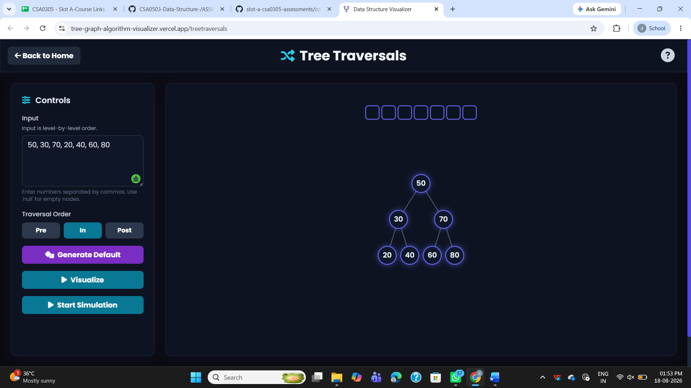
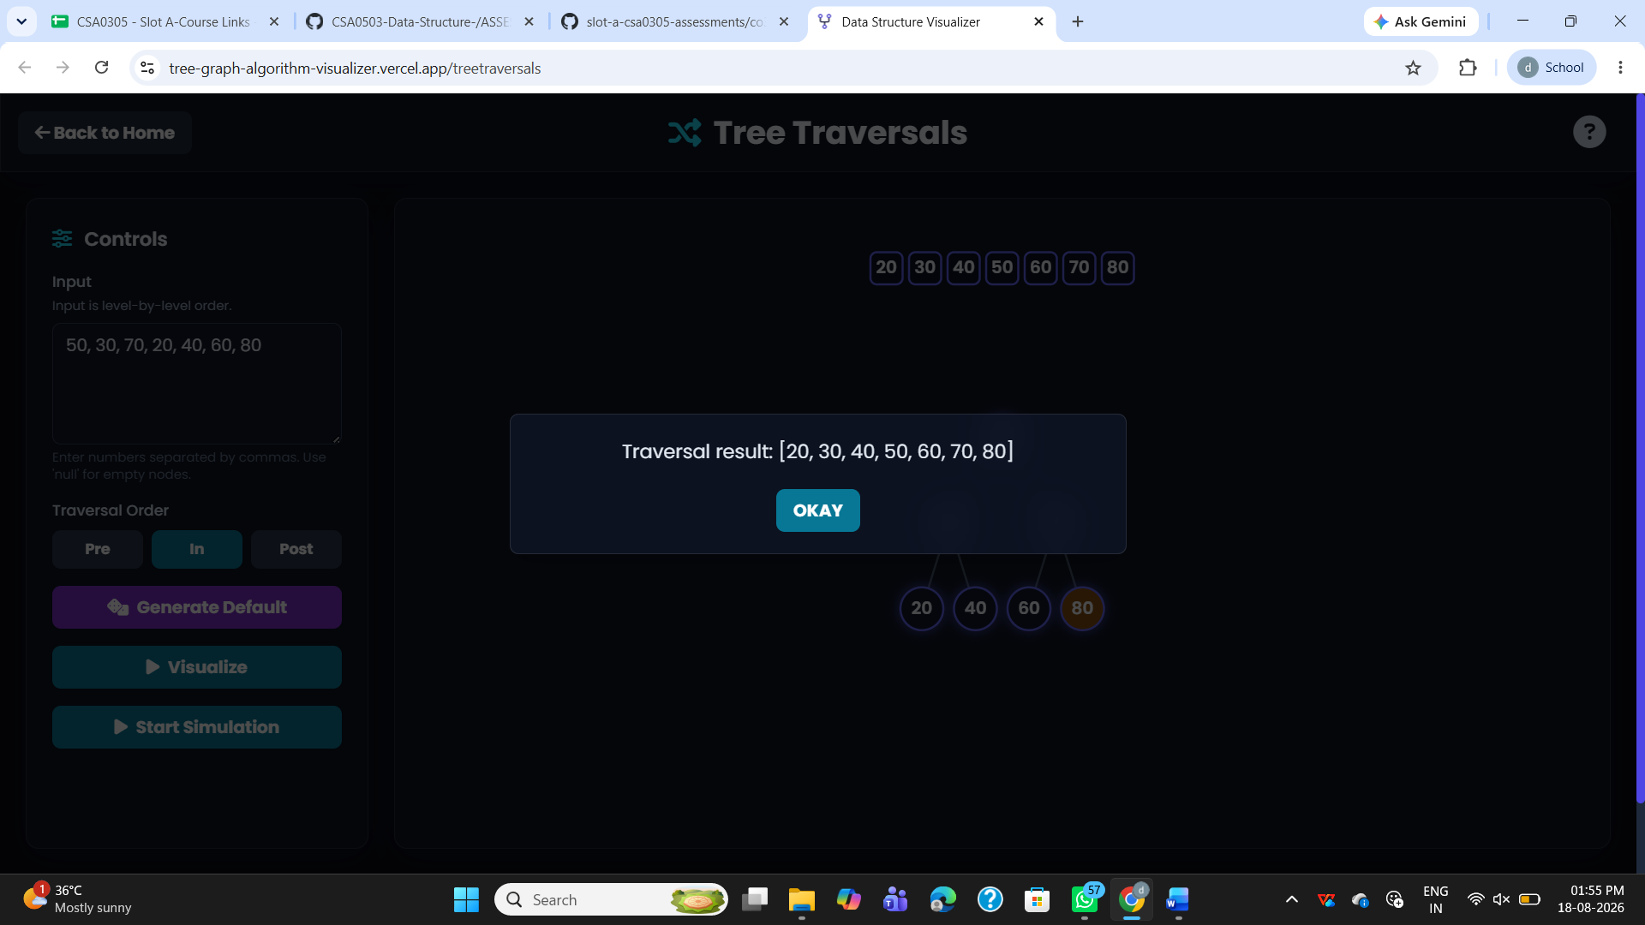

b.Search for 60
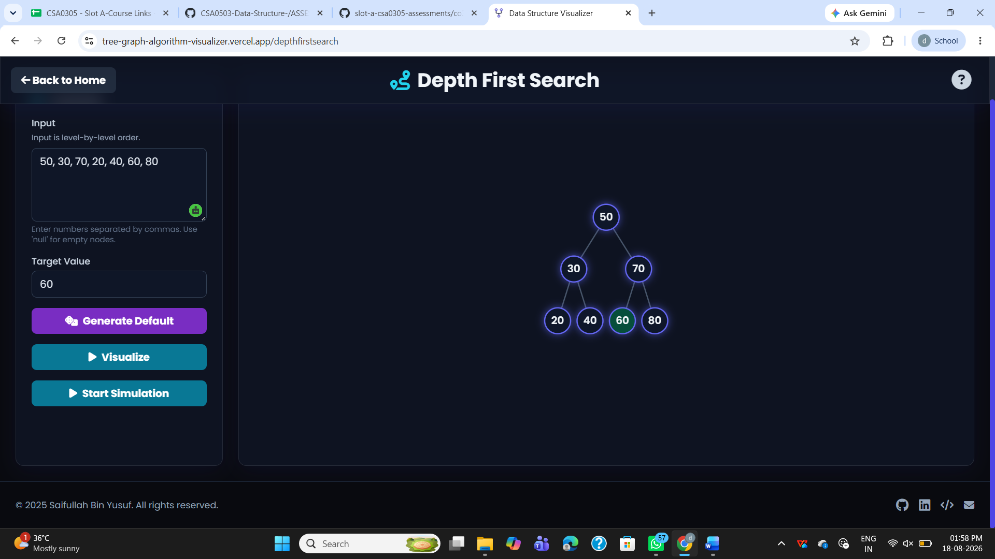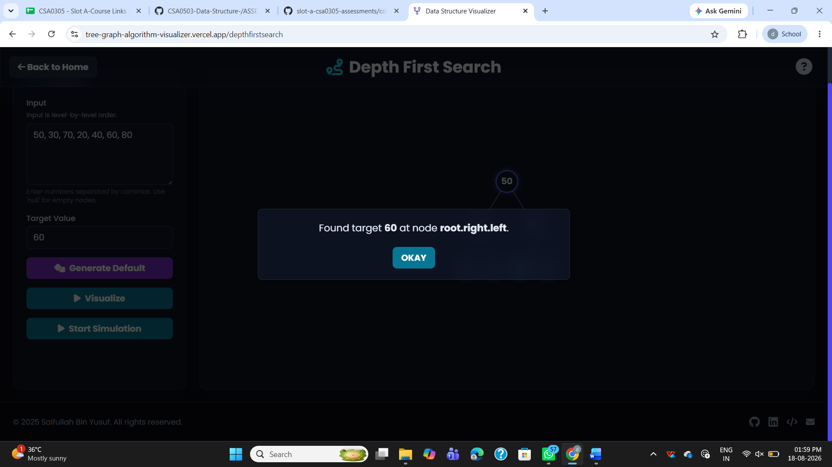

- Delete 30
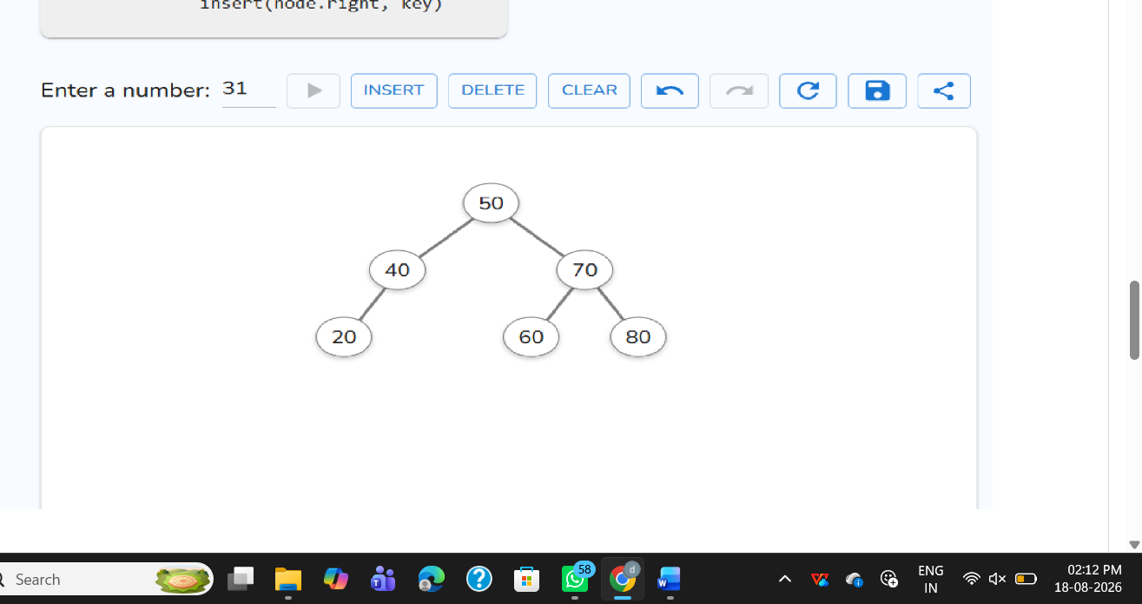

d.Display the final BST.
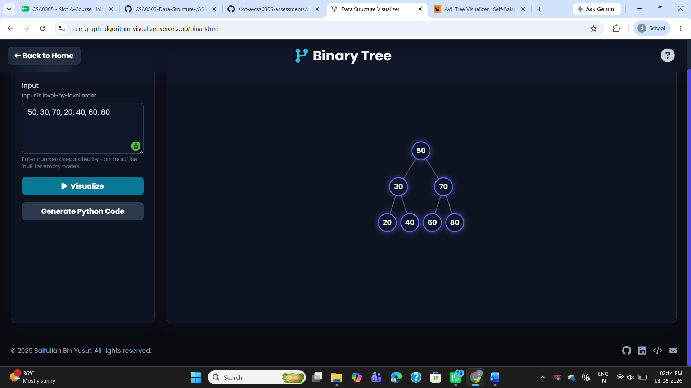

2.Complete Tree Traversals by Inserting 50, 30, 70, 20, 40, 60, 80 Find all the traversals. a. Inorder

- Inorder
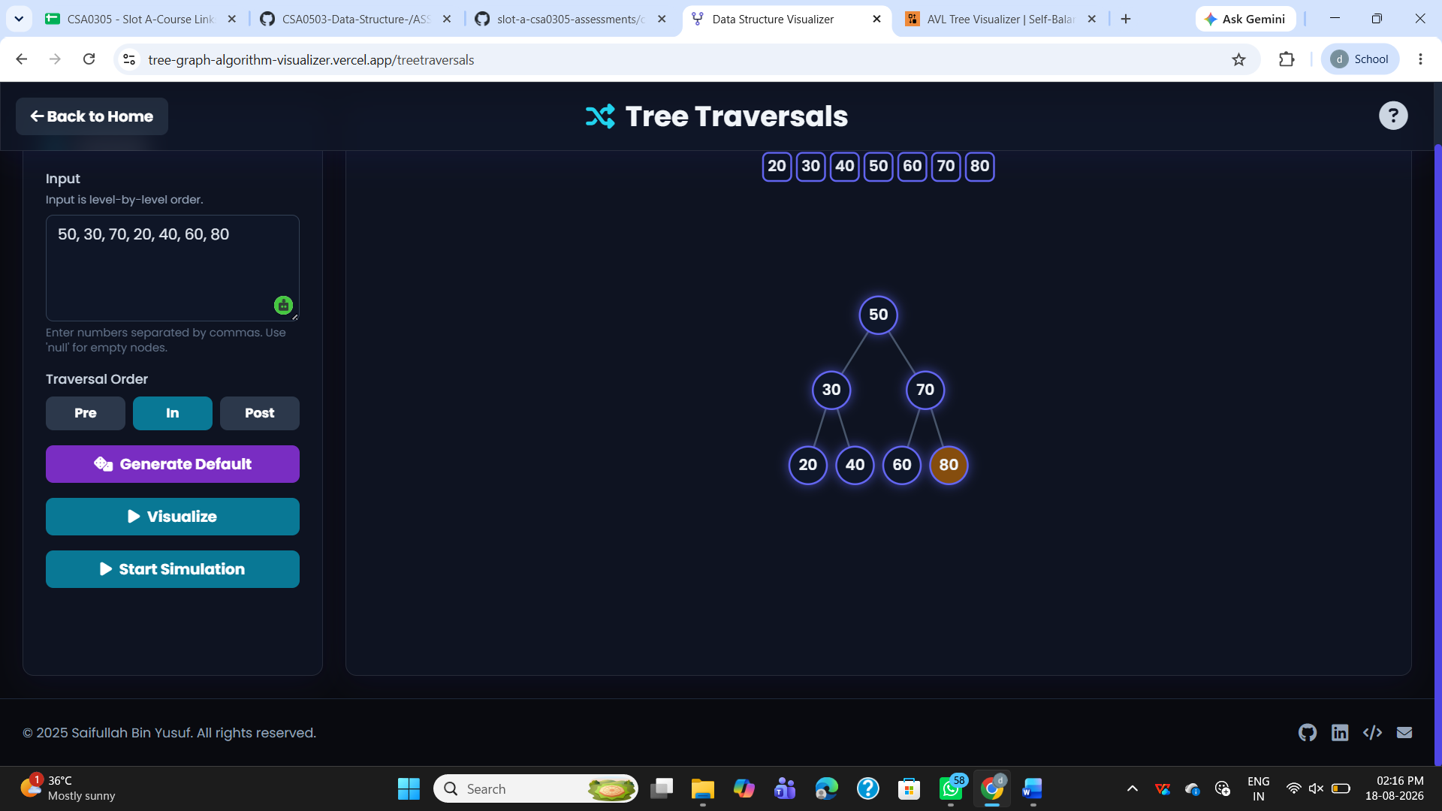
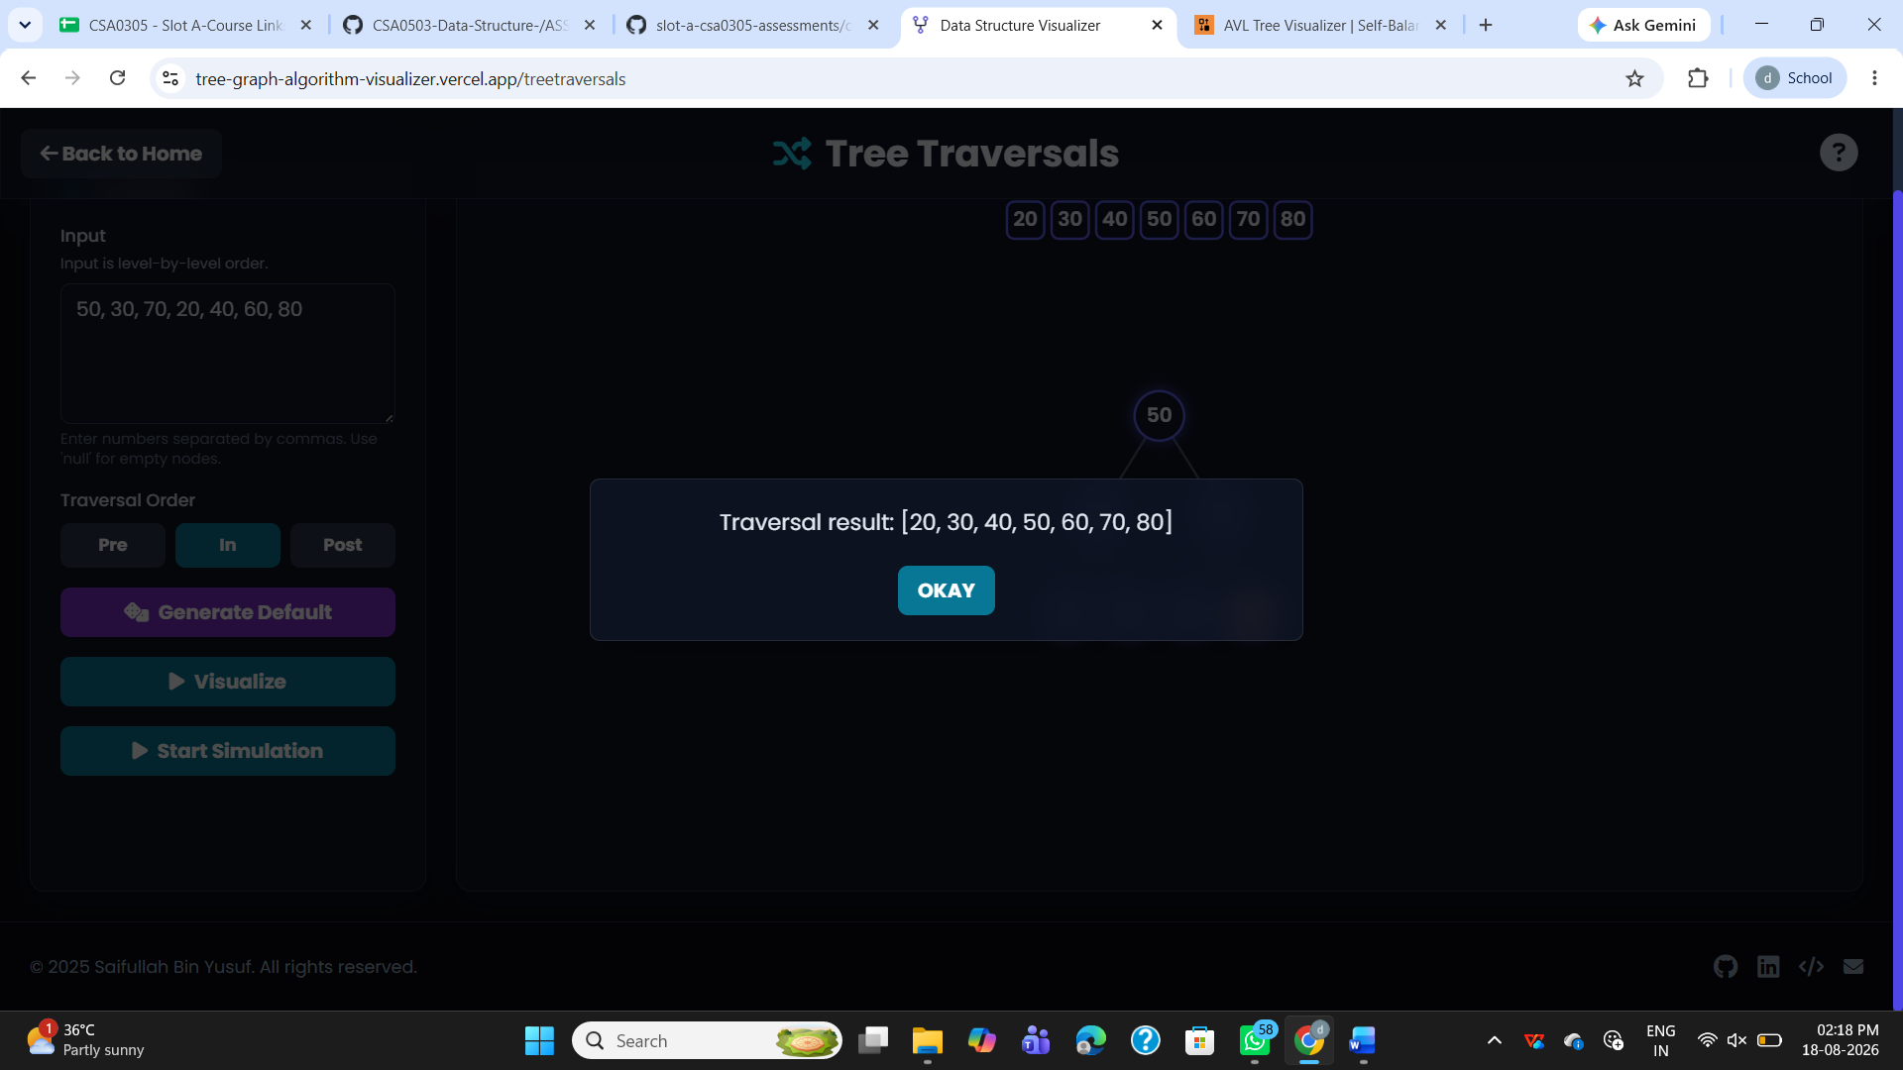

- Preorder
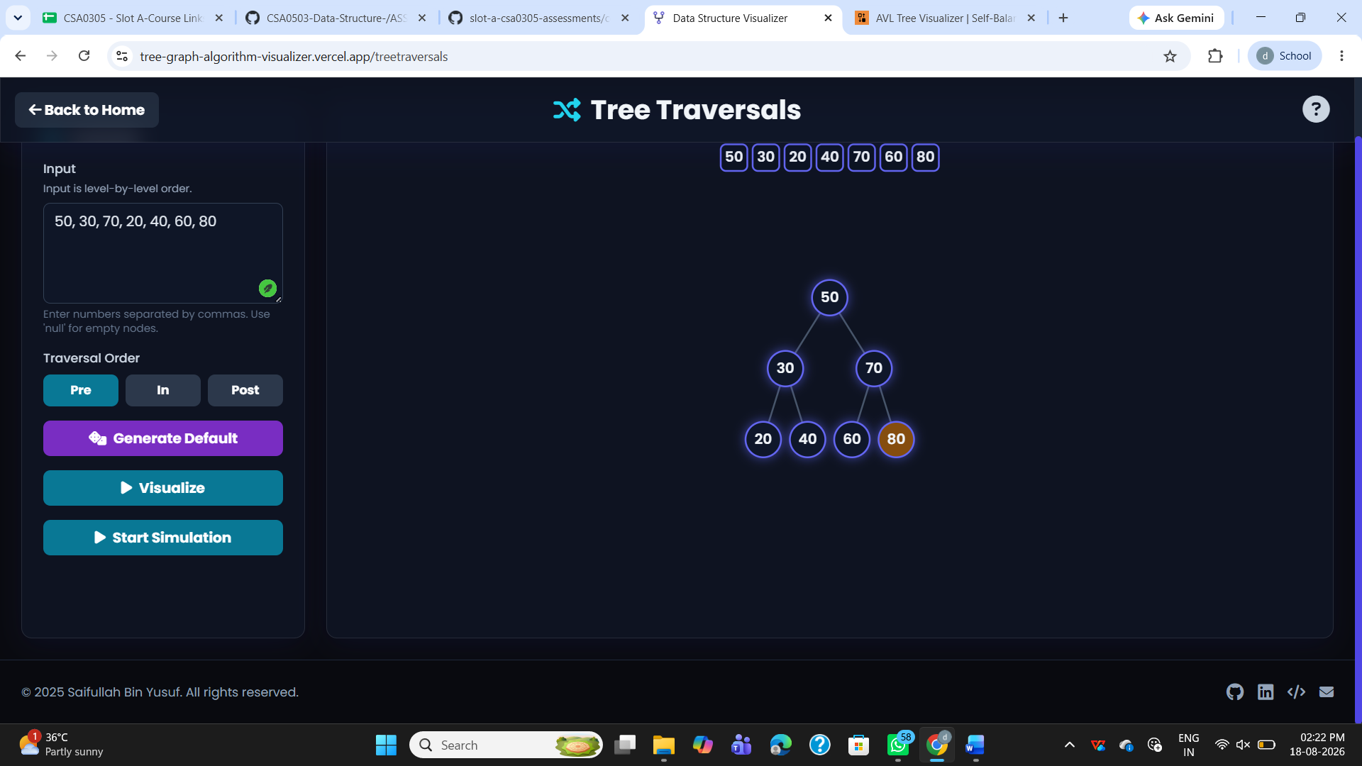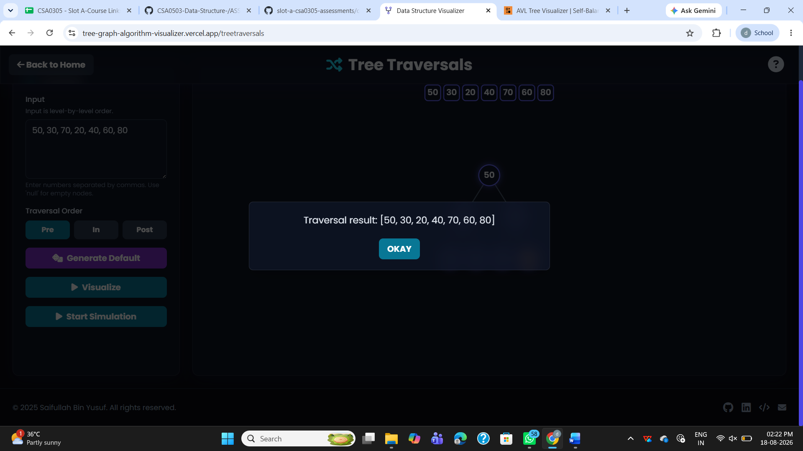

- Postorder
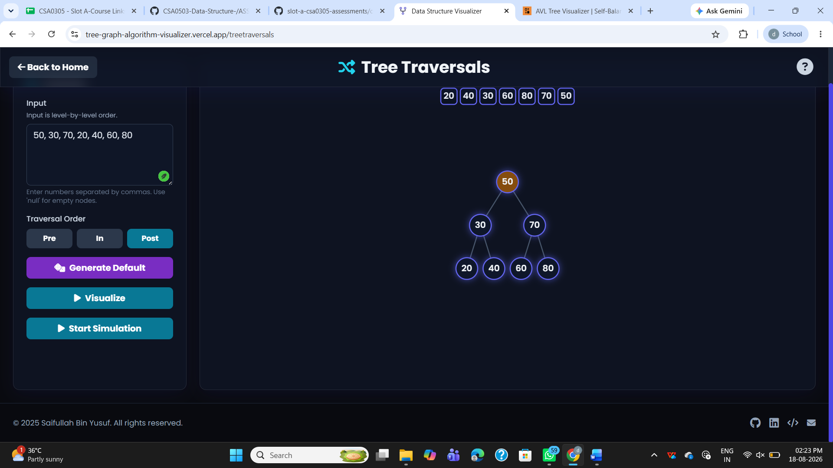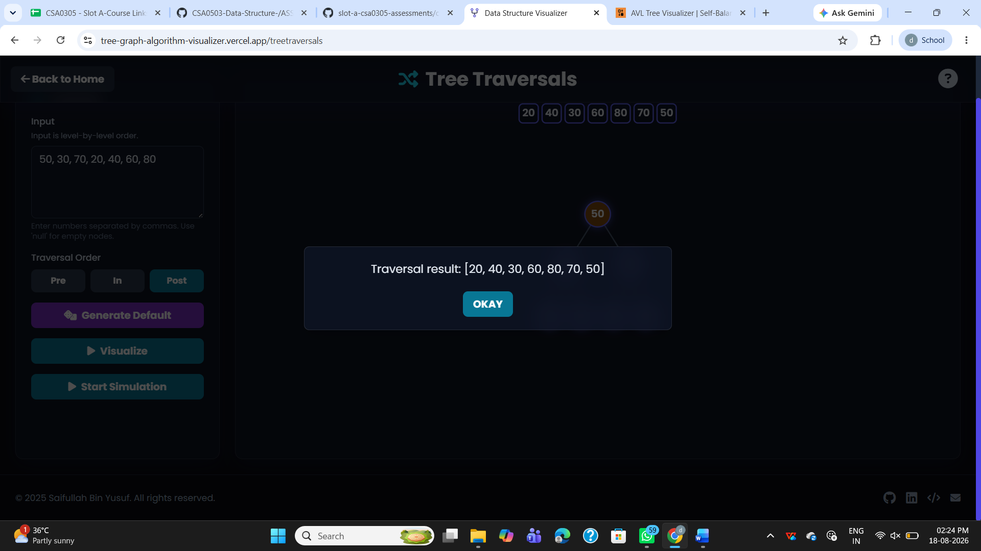

3.Insert 70, 50, 90, 40, 60, 80, 100, 55 into an AVL Tree. Delete 40 and 90. Analyze how the tree rebalances after each deletion.
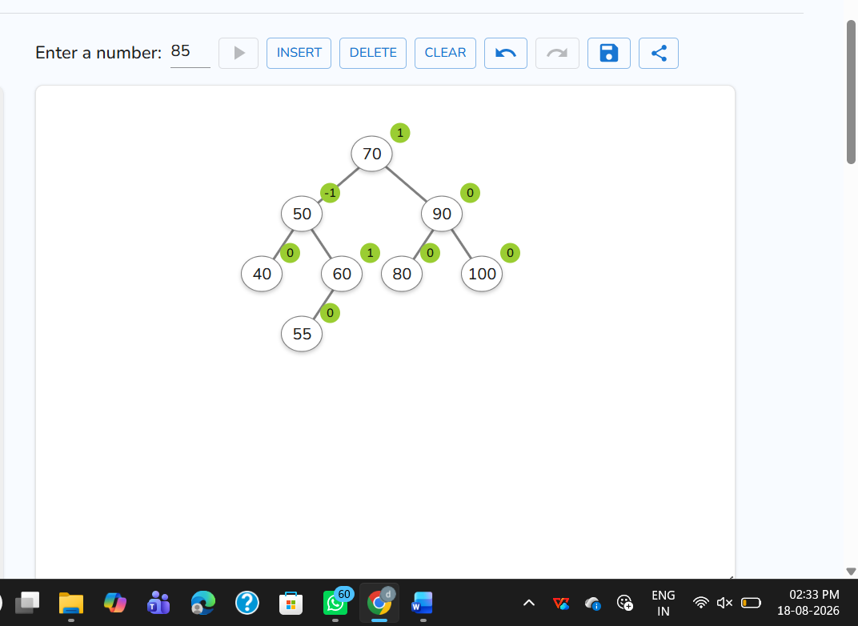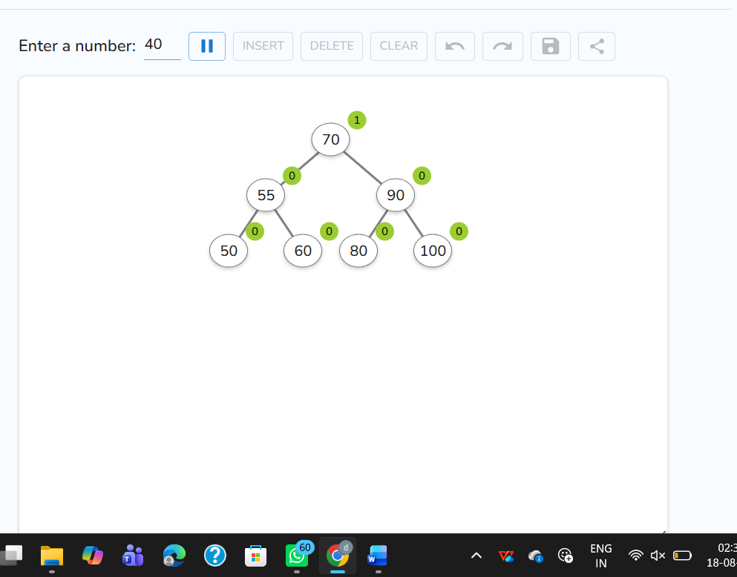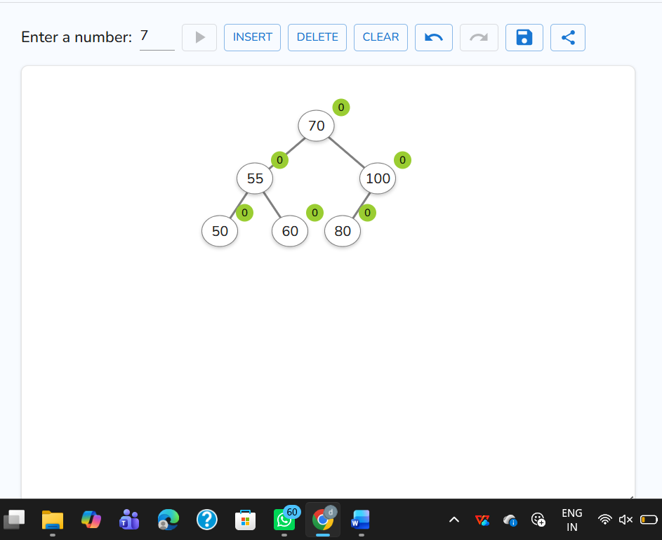

4. Construct a B-Tree of order 3 by inserting 45, 25, 65, 15, 35, 55, 75

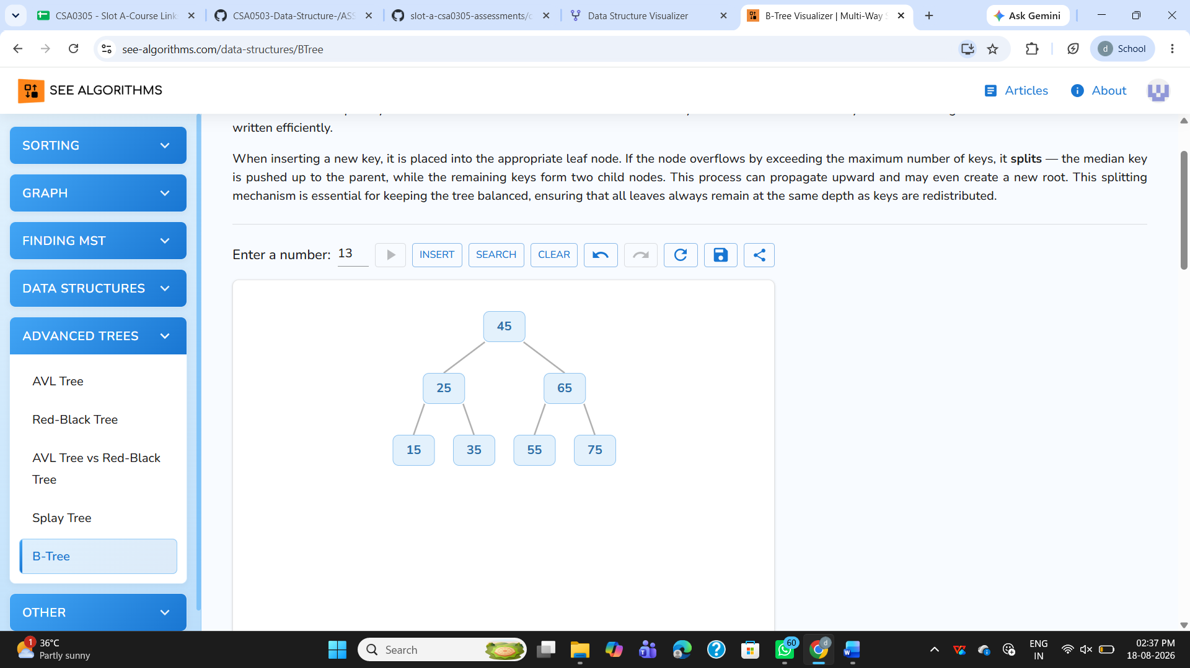

5.Insert 100, 80, 120, 60, 90, 110, 130 into a Red-Black Tree. Analyze their heights.
